2.1 Busbars and the BusbarGroup

The objective here will be the mapping of *BusbarSection (BBS)* to *BusbarGroup (BBG)* to hold the fault and relevant capacity data. Is there a reason this fault/capacity information has been mapped to the new object BBG via BBS? In some cases, this may provide a confusing situation. The BBSs can all be conductors connected to *ConnectivityNodes*, but as soon as those BBSs are collected by the same group the fault information can no longer be attributed to individual busbars since the group holds all that information. This makes sense for specific conductors in a substation or something that the BBG will equivalence a busbar, but if your topologies have equivalents redacted across the network, does this mean every node will have a BBS and a BBG? This seems expensive. Some clarification on this decision would be helpful.

BusbarGroup is intended to support the representation of the information present in these three existing LTDS tables:

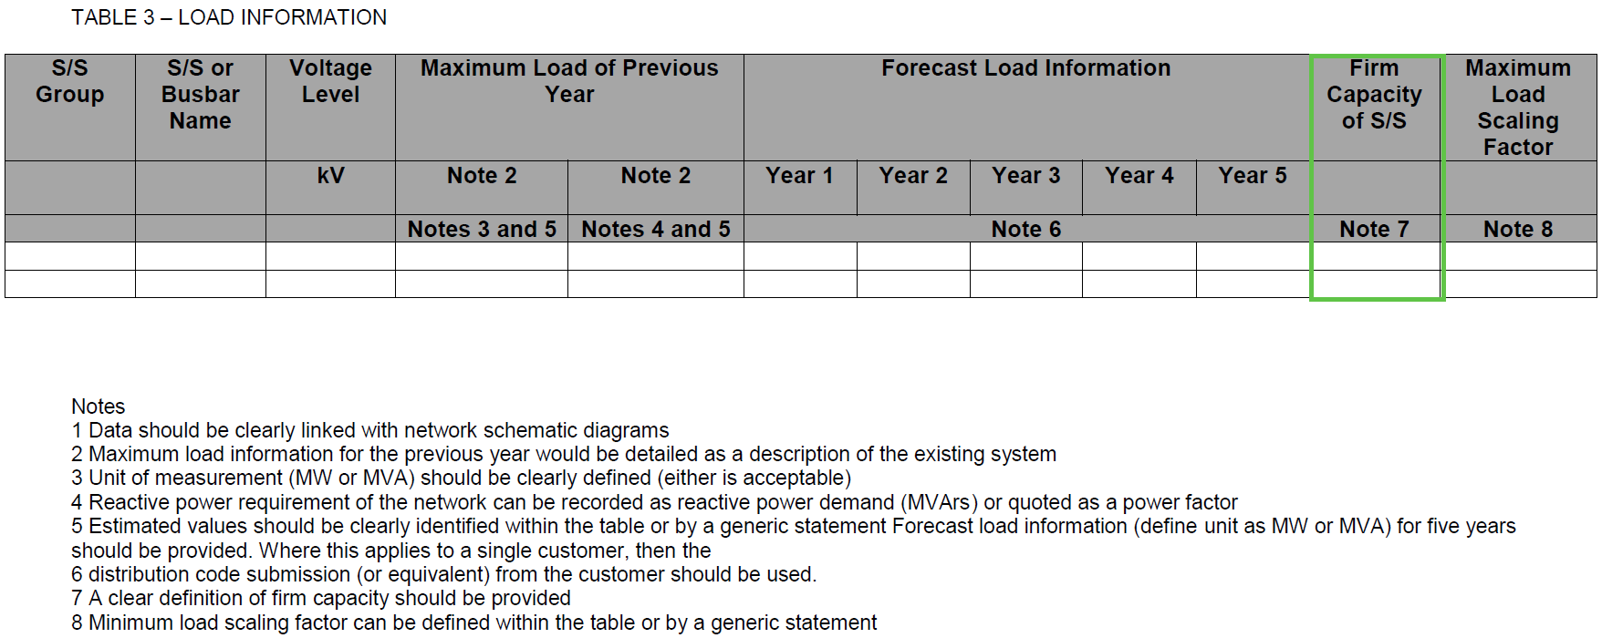

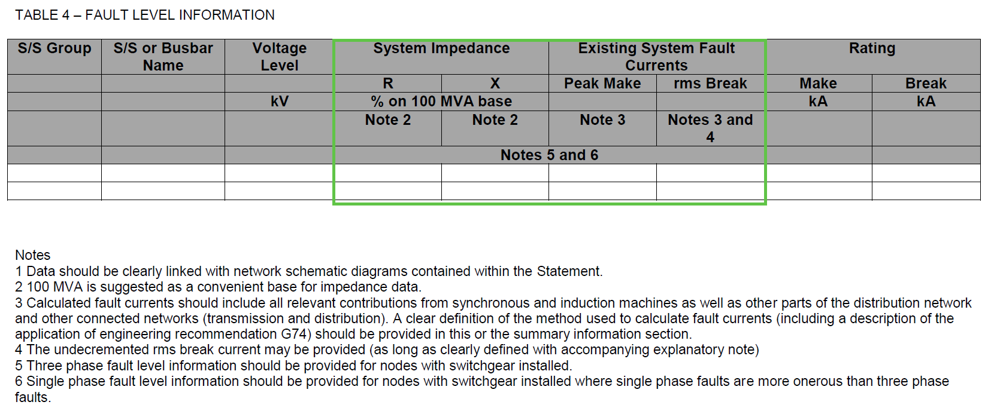

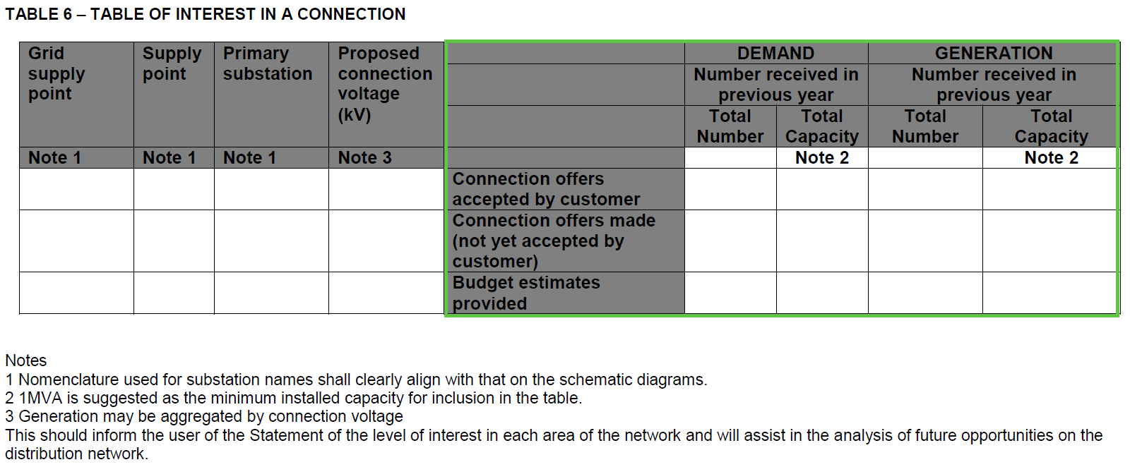

From the LTDS submissions we evaluated (UKPN’s Maidstone, in particular), these values were reported at the locations shown in the blue and green boxes:

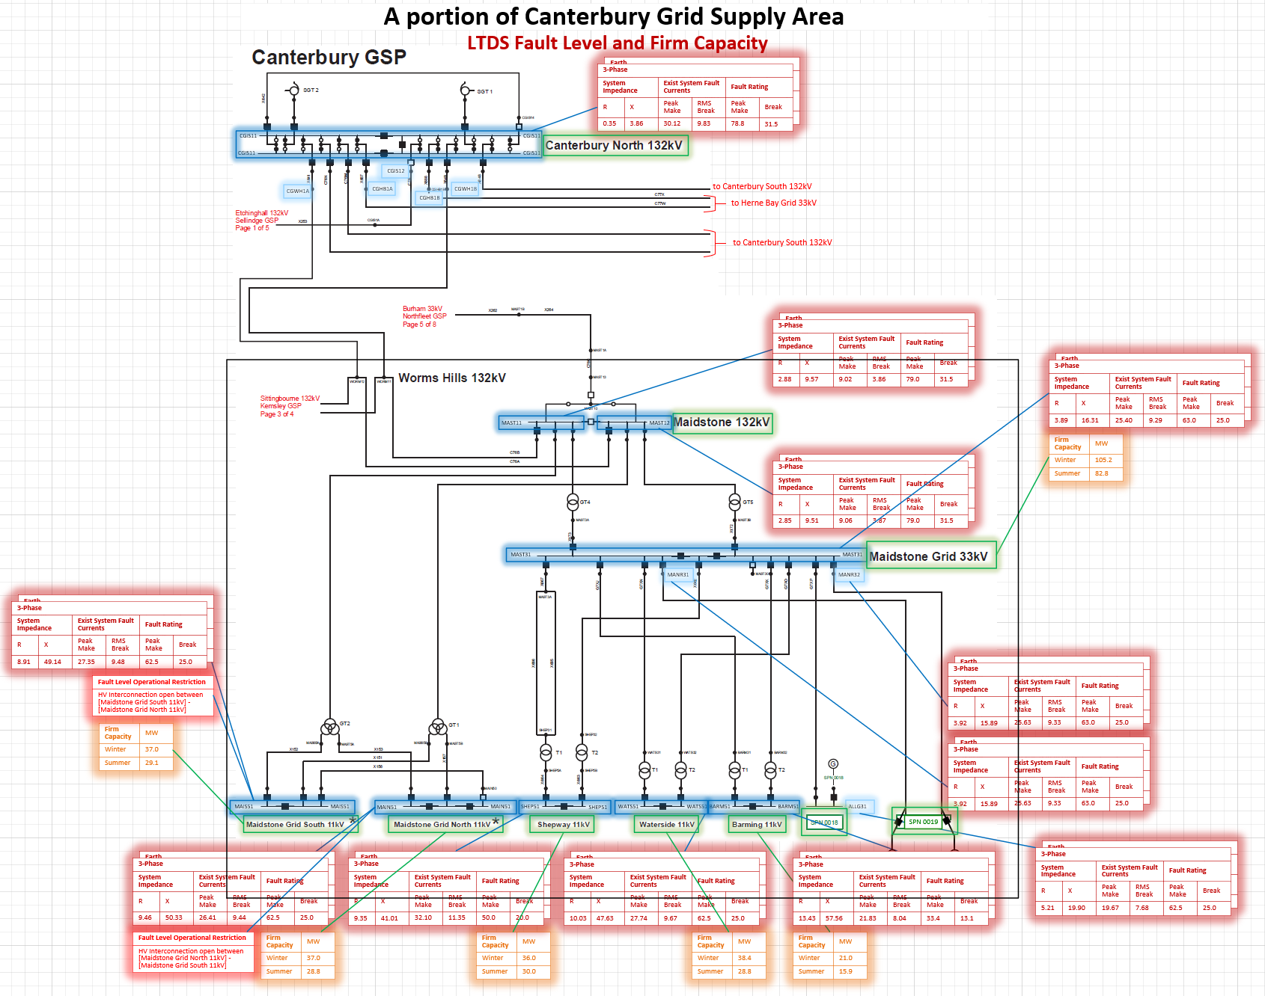

As LTDS in CIM modelling essentially requires every breaker to be modelled (with the exception of ‘lowest level’ (e.g., 11kV) bus coupling breakers), there could be multiple BusbarSections present in the LTDS in CIM modelling for which one set of loading, firm capacity, fault level, and connection activity information would have been reported under the existing LTDS. Rather than increase the granularity of reporting, the BusbarGroup was created.

2.1.1 Boundary Busbars

A new class called *BoundaryPoint* is included in LTDS this replaces the need for EQBD profiles but requires us to know where to make them. This has two options: the first option is where we simply create one on the busbar connected to the equivalent injection radials, alternatively the second option is to include a busbar type in IPSA called “boundary” which indicates it should have a *BoundaryPoint* this would allow more elaborate boundaries to be created. Some further clarification on why the *BoundaryPoints* are included when we negotiated sidestepping EQBD like data is also worth knowing a bit more about as well.

You are correct, BoundaryPoint ConnectivityNodes are not strictly necessary for LTDS reporting as there isn’t a requirement to ‘stitch together’ modelling across distribution licence areas, but we had the following thoughts in mind when we decided to include them in LTDS in CIM:

* BoundaryPoint is an already-defined CGMES v3.0 class
* Their use could help support the sharing of the cross-licence area flow information (T-to-D or D-to-D) needed by DNOs to construct their NETS peak/minimum SSH models
* Their use could make clear where a DNO is providing data whose original source is not the DNO (useful on the boundary with the transmission system)
* We were also looking ahead to the potential requirements which the GC0139 revision of the planning code might introduce, with the intention of defining a CIM modelling approach to boundaries that would work for both. (We’ve subsequently learned more about the these requirements and realise that the diagrams in the LTDS Grid Modelling Guidelines are too simple.)

2.2 Line Containment and Circuit

Disconnectors can be added to lines now, as they currently have an *EquipmentContainer*, LTDS required the addition of a *cim:Equipment:AdditionalEquipmentContainer*. This in principle is fine, but this also seems to extend to *ConductingEquipment* in general. Does this mean that the *Line* is now an equivalent branch container also? In short, we need more detail on this object and the way it has been developed within GB-CIM.

Use of the ConductingEquipment.AdditionalEquipmentContainer association is optional and is included in LTDS in CIM to allow a utility to express the fact that a piece of equipment (like a line disconnector or breaker) could be viewed as associated with a line for operational or maintenance purposes, but could be associated with a substation for naming or display purposes. The association addresses a complaint that has been commonly raised by CIM implementers. Just a note that this association, like all containment in the CIM, exists only to assist in human interpretation - there is no intention to support any sort of grid analytical function.

2.3 Circuit/Operational Limits

Every *ACLineSegment* (ACLS) needs at least one *OperationalLimitSet* (OLS); between N OLSs they need to cover the entire calendar year as well. Each OLS must connect to a *CurrentLimit* (CL), and this is all very well explained. Is there a restriction on how DNOs must present season by season or is it just for a full year? Some more rigid clarification on this would be helpful as well.

The minimum number of (seasonal) OperationalLimitSets (OSLs) for ACLineSegments is one (bottom of p 19 of LTDS Grid Modelling Guidelines). Any number can be used and they can apply to any annual time period. (There was divergence among the DNOs in their seasonal (or not) limit management. This solution was intended to allow a user to pick time of year for which a study was being built and find the normal limits in effect at that time, regardless of how the DNO managed its limits.)

The minimum number of OCLs for PowerTransformers is two (one for summer and one for winter). It is two because the majority of DNOs seemed to provide summer and winter in their existing LTDS publications, even though definitions of season start/stop dates varied. (Note that transformers have additional OSL requirements for 3-winding transformers and transformers that support reverse flow.)

2.4 Generation

In reactive capability curves, the data required involves a *ReactiveCapabilityCurve* CIM object tied to a *CurveData* subset that involves X and Y data pertinent to the curve. However; this data is typically quite vast with details on the basic D-curve and the primer modifications. Most software that supports RCCs allow for basic P vs. Q variations as the generator changes through load flow iterations. Is LTDS expecting a dense/complete representation? If there must be a curve compulsorily (as stated in Annex 1-2 with focus on non-inverter-based generator), how do the DNOs find and represent that data if that is omitted/not necessarily available? These are all questions that just require a small clarification.

The reactive capability curve needs to be provided only if meaningful data is available. If the reactive capability curve is not provided, the following attributes must be populated:

* SynchronousMachine.maxQ
* SynchronousMachine.minQ
* GeneratingUnit.maxOperatingP
* GeneratingUnit.minOperatingP

Section 4.3.2.7 Generation of the Grid Modelling Guidelines will be updated to reflect this.